Name: |  | ___________________________________________________ |  |  |  |  |  | Date: ___________
 |  | Subject :Year 11 Applications  Test 5, 2015  Topics – Linear equations, simultaneous equations, piece-wise functions and normal distribution |  |  |  |  |  | 60  = %
Total Time: |  | 60 minutes
Total Reading: |  | 5 minutes
Total Working: |  | 65 minutes
Weighting: |  | 10% of the year.
Equipment: |  | Curriculum Council Formula Sheet; ½ page notes (A4 one side), CAS calculator; Scientific Calculator
SECTION 1: CALCULATOR FREE
Time: |  | 26 minutes |  | Marks for Section 1: |  | 24 marks
Reading: |  | 2 minutes |  | Equipment Allowed: |  | Nil
Working: |  | 24 minutes
1. | [ 6 marks: 1, 1, 1, 1, 1, 1, mark each]  Solve the following equations:
 | - 5x + 3 = 63 |  |  |  | - -7 – 2y = 23
 | - 5h + 13 = 2h – 2 |  |  |  | - 14 – 4d = 27 – d
2. | [ 3 marks: 1, 2]  The cost of hiring a limousine for the year 12 ball is $175 plus $3.50 for each kilometer travelled.
 | - Construct a formula to calculate the cost of hiring a limousine with this company
 | - Calculate the cost of hiring a limousine to travel 36km
3. | [ 6 marks: 1, 1, 2, 2]  Graph the following linear functions on the number plane provided:
 | - x = 5 |  |  |  | - y = ½ x
 | - 2x – 8y = 20 |  |  |  | - 6x – y + 3 = 0
 | 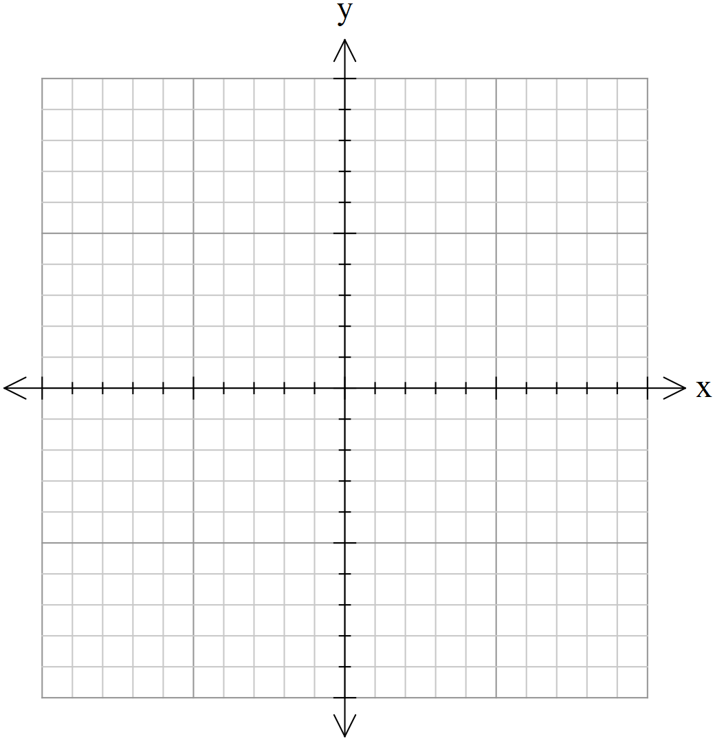
4. | [ 3 marks: 1, 1, 1]  Write the linear equation for the following table of values:
 | a) |  | b) |  |  |  | c)
  x | 0 | 1 | 2 | 3 | 4 | 5
  y | 1 | 5 | 9 | 13 | 17 | 21
  x | 6 | 7 | 8 | 9 | 10 | 11
  y | 8 | 10 | 12 | 14 | 16 | 18
  x | 2 | 4 | 1 | 5 | 3 | 9
  y | 1 | 7 | -2 | 10 | 4 | 13
5. | [ 6 marks: 1, 2, 3]  Solve the following simultaneous equations:
 | a) y= 2x + 6  y + 3x = -4 |  |  |  | b) 10x + 11y = 37  5x – 22y = 51
c) 3x + 5y = -9
7x + 4y = 2

~ END OF TEST SECTION 1~

Name: ____________________________________ | Date:
SECTION 2: CALCULATOR ASSUMED

Time: | 37 minutes | Marks for Section 2: | 37 marks
Reading: | 2 minutes | Equipment Allowed: | ½ page notes(A4 one side), CAS calculator
Working: | 39 minutes

6. [ 5 marks: 1, 1, 3]
The value (V) of a car t years after it is purchased is given by the equation V = 350 – 80t.
- Find the value of the car when it was new

- After 5 years

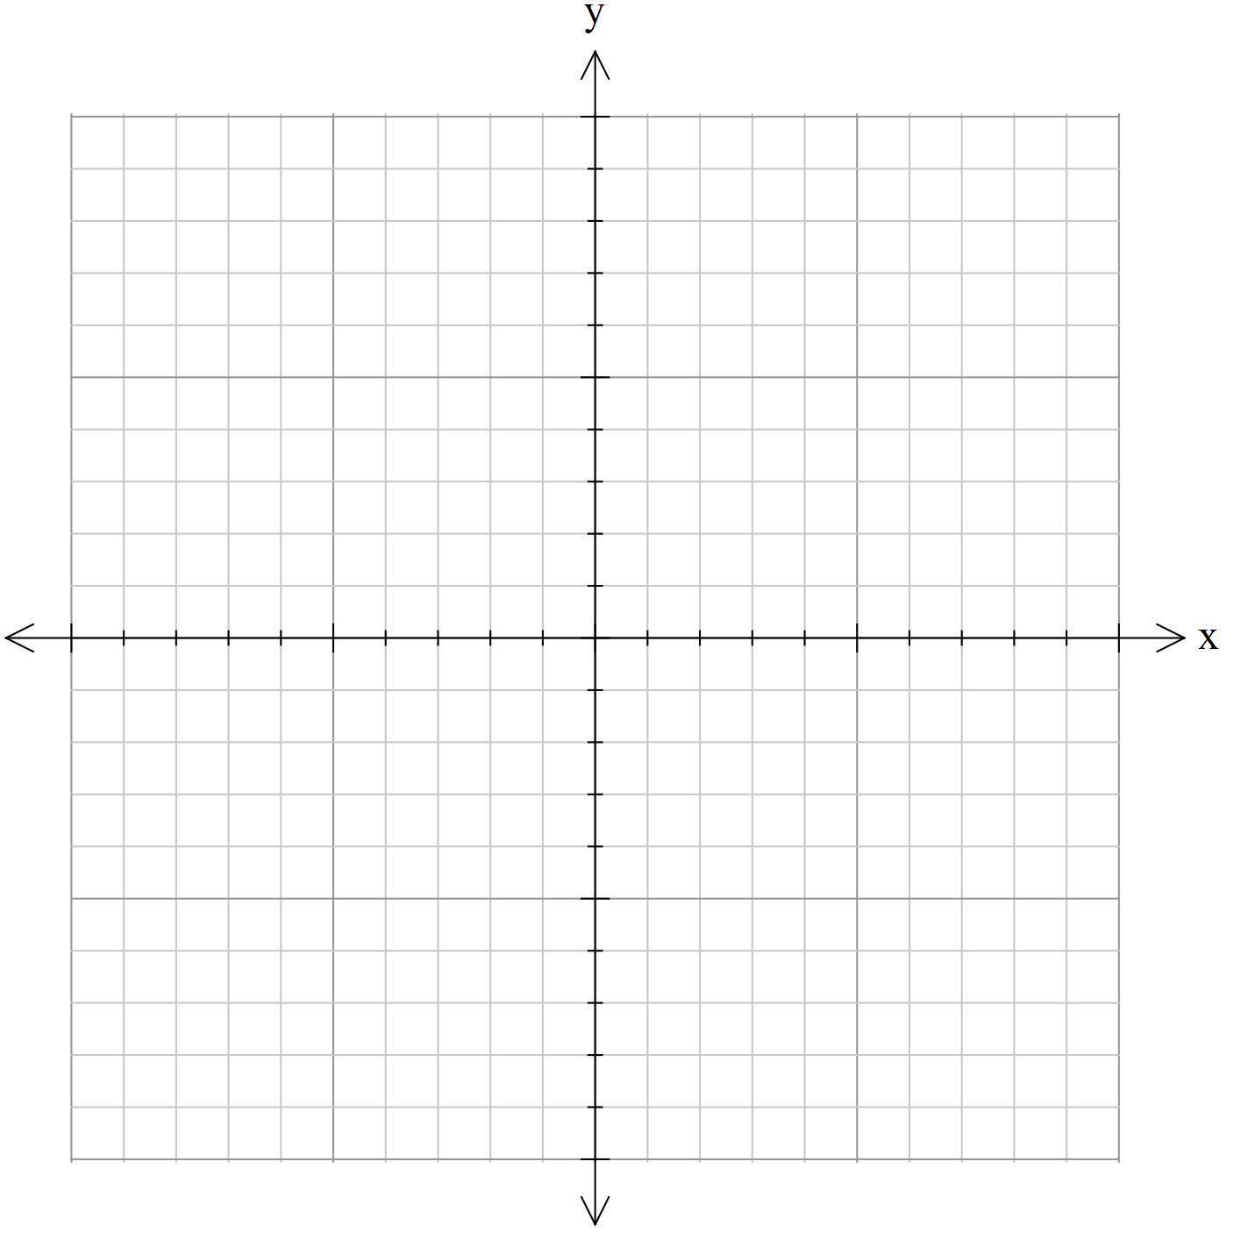
- Plot the relationship.

7. [ 2 marks]
A swimming pool is being filled at a constant rate so that after 4 hours it contains 5000 liters, and 3 hours later it contains 9500 litres. Write an equation representing this relationship, letting V be the volume in the pool after t hours.
8. [ 3 marks: 1, 1, 1]
Find the equations of the line that passes through the points below:
- (-1, 3) (0, 4)

- (-2, -2) (0, 2)

- (5, 5) (1, 3)

9. [ 3 marks: 1, 1, 1]
Find the equation of the line given the gradient and one point:
- m= 6 (-1, 5)

- m= -2 (0, 3)

- m= -10 (9, -1)

10. [ 2 marks: 1, 1]
Find the equation of the line from the following graphs:
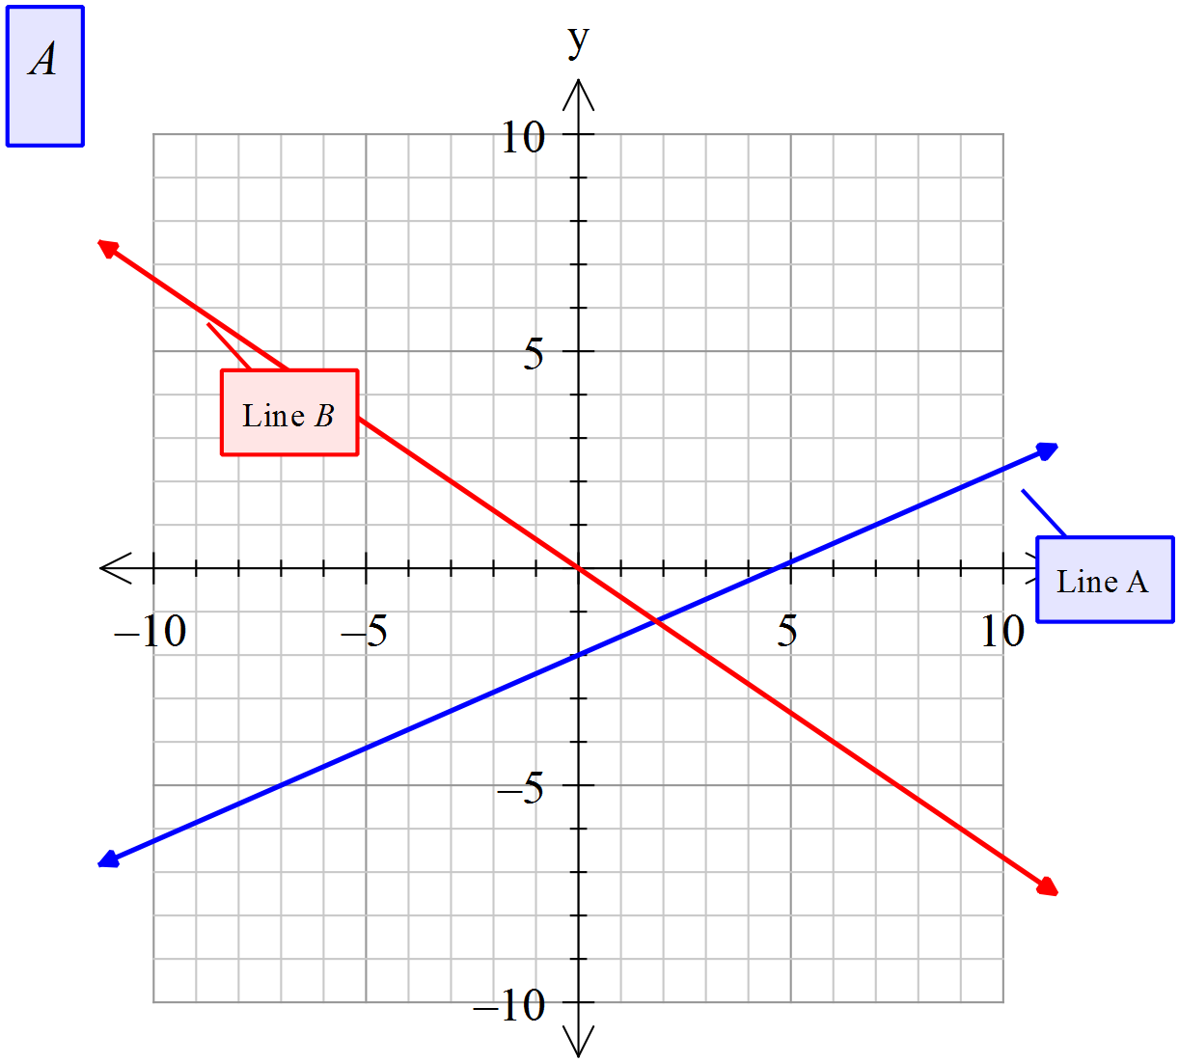
- Line A | - Line B
11. [ 3 marks: 2, 1]
The year 12’s are looking at transportation to their school ball. A hummer limo can carry 10 people, and a normal taxi can carry 2 people. There are 40 people that need transportation, and they need 8 vehicles for safety requirements.
a) Write the simultaneous equations for this information

b) Find the number of hummer limo’s and taxi’s they will need
12. [11 marks: 2, 6, 3 ]
A real estate agent charges the following commission rates for selling property.
- 8% of the first $70 000 of the properties price
- 5% of the next $80 000
- 3.5% of the remaining amount

- Complete the table of values using the rates given above:
Property price ($P) | 0 | 70 000 | 16 0000 | 800000
Commission (C)

- Use the table above to help you draw a piecewise graph displaying the agents commission for property values from $0 to $800 000
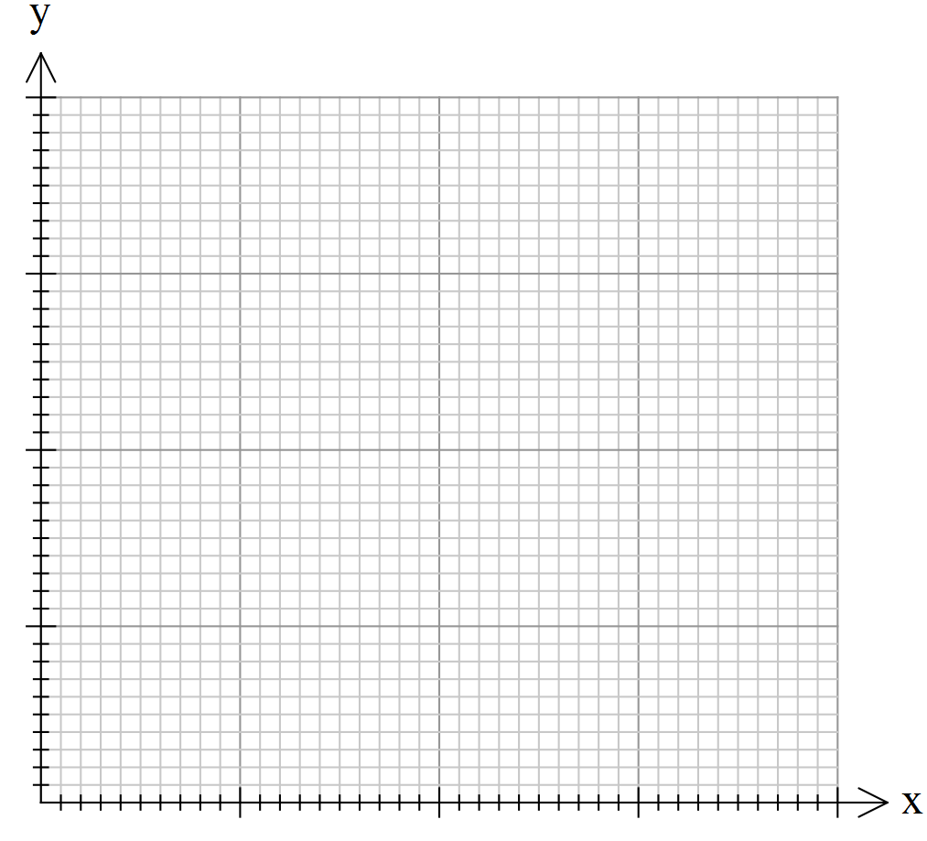
- Use the graph to find the commission earned for selling:
- A unit for $115 000
ii. A house for $370 000
iii. A farm house and land for $730 000
13. [ 4 marks]
Graph the following step graph, showing the cost ($C) for the number of hours (n) spent in a car park:
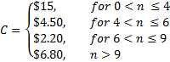
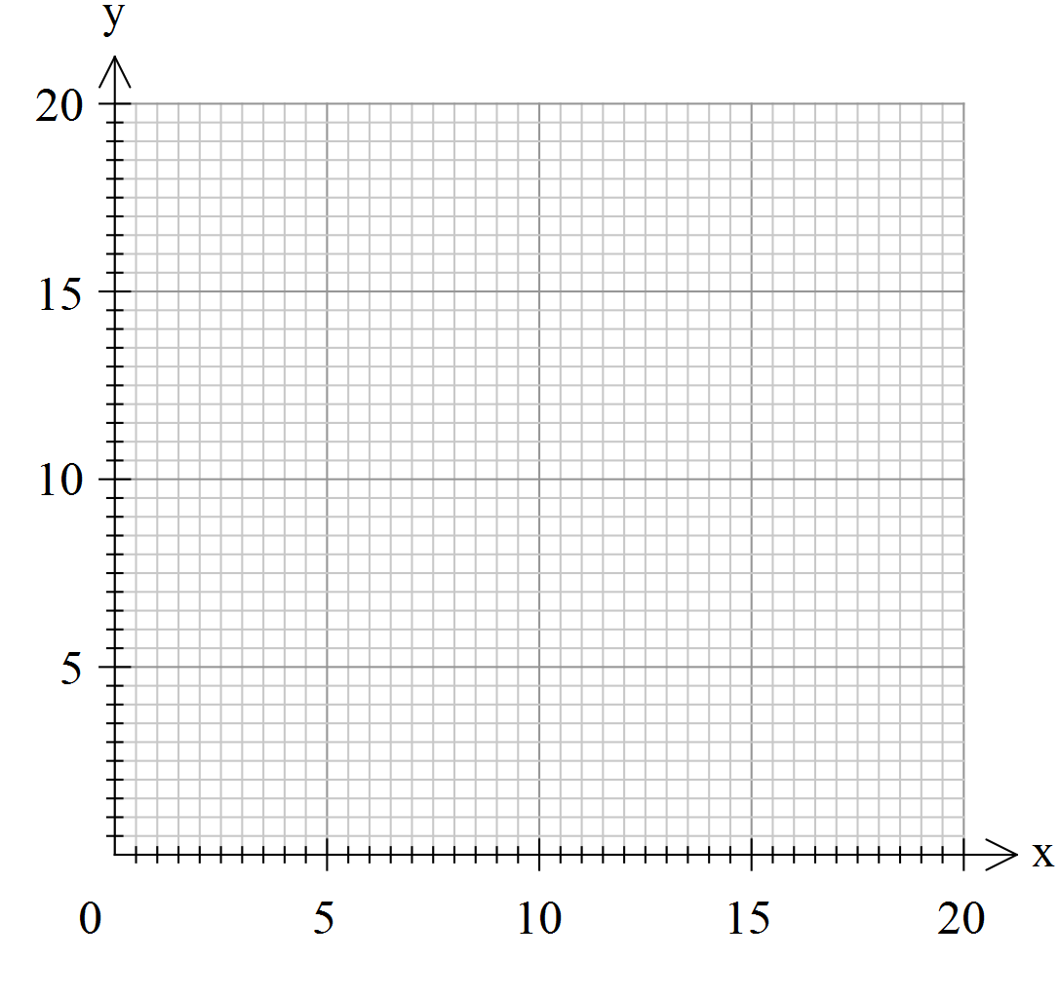
14. [ 4 marks: 2 , 2]
352 year 11 applications students at Springfield Elementary sat their final examinations. The scores obtained were normally distributed, with a mean of 57 and a standard deviation of 9.5.
  - Scholarships were awarded to students who gained a mark of 85 or above. How many students gained scholarships?

  - A mark of less than 45 was considered a fail. How many students failed?

~ END OF TEST SECTION 2 ~

